THE SUPERIOR University Lahore


Faculty of Computer Science & IT

FINAL YEAR PROJECT
PROJECT PROPOSAL & PLAN

Health Guardian

Project ID: FYP-BCSM-F23-039

Project Team
Student Name | Student ID | Program | Contact Number | Email Address
Ali-Akbar | BCSM-F20-314 | BSCS | +92 319 7600294 | bcsm-f20-314@superior.edu.pk
Obadah Junaid | BCSM-F20-355 | BSCS | +92 309 4110292 | bcsm-f20-355@superior.edu.pk
Ali-Mujtaba | BCSM-F20-060 | BSCS | +92 304 9171641 | Bcsm-f20-060@superior.edu.pk

Project Supervisor

Mrs. Arshia Naeem
Health Guardian

Change Record

Author(s) | Version | Date | Notes | Supervisor’s Signature
 | 1.0

Project Proposal
Project Title: Health Guardian

Executive Summary
The "Disease Prediction and Medication Recommendation System" is an advanced healthcare application catering to patients and doctors. It enables patients to input their symptoms, predicting potential illnesses, and suggesting suitable medications. In cases where a confident diagnosis cannot be made, the system advises users to seek medical consultation. This user-friendly system seamlessly blends machine learning with healthcare, promoting early disease detection and informed health decisions. It prioritizes data privacy and security while enhancing healthcare accessibility and user experience.

Introduction
The "Disease Prediction and Medication Recommendation System" is an innovative healthcare solution designed to assist users in predicting potential illnesses based on reported symptoms and providing medication recommendations. This system caters to two primary user roles: patients and doctors. Patients can input their symptoms, and the system predicts potential diseases and suggests appropriate medications. If a confident diagnosis cannot be made, the system recommends consulting a medical professional. Doctors, on the other hand, have access to patient symptoms and can provide further medical guidance.

- Existing System / Competitive Analysis
In the healthcare technology landscape, several existing systems and solutions provide various levels of symptom analysis and disease prediction. To ensure the success and uniqueness of the "Disease Prediction and Medication Recommendation System," it's essential to conduct a competitive analysis of these systems. While existing systems provide valuable resources and services, the "Disease Prediction and Medication Recommendation System" aims to stand out by combining symptom analysis, medication guidance, and user roles. Its focus on accuracy, user privacy, and integration potential positions it as a promising solution in the healthcare technology landscape

- Solution: Our system offers both symptom analysis and medication recommendations, filling the gap left by existing systems.
- User Roles: By catering to both patients and doctors, we create a holistic healthcare ecosystem that encourages early detection and timely intervention.
- Machine Learning: Our system utilizes machine learning models for disease prediction, enhancing accuracy over rule-based systems.

- Problem Statement
In today's fast-paced world, access to accurate healthcare information and timely medical advice is of paramount importance. However, many individuals face challenges in seeking early guidance for their health concerns, often leading to delayed diagnosis and treatment. This project aims to address this critical issue by developing an Intelligent Disease Prediction and Medication Recommendation System. Many individuals experience health-related symptoms but may not have immediate access to medical professionals or resources to determine the potential causes of their ailments. This often results in delayed medical attention, potentially exacerbating their conditions.

Proposed Solution
We propose the development of an Intelligent Disease Prediction and Medication Recommendation System. The system will allow registered users to input their symptoms through a user-friendly interface. Upon symptom input, the system will utilize machine learning algorithms and medical knowledge databases to predict potential diseases. It will then provide medication recommendations for those diseases, ensuring users have access to initial treatment guidance.
Software Components:
- User Interface (UI)
- Machine Learning Engine
- Medication Recommendation Module
- Database Management

- Scope of the Project
The project aims to develop an Intelligent Disease Prediction and Medication Recommendation System, catering to both patients and doctors. It will feature user-friendly registration and authentication, allowing patients to input symptoms for disease prediction. Utilizing machine learning algorithms and medical knowledge databases, the system will provide accurate disease predictions and medication recommendations. User roles will distinguish between patients and doctors, with additional privileges granted to medical professionals for further guidance. Secure communication features will facilitate real-time interactions within the platform. Robust data security measures will ensure privacy compliance, and comprehensive documentation will support system maintenance. Scalability, testing, deployment, user training, and continuous improvement are integral components of the project's scope.

- System Architectural Design
The architectural design of the system is structured to ensure scalability, reliability, and security while providing a seamless user experience. The following components make up the system architecture:
User Interface (UI):
- The UI is accessible through web browsers and mobile applications for both patients and doctors.
- Patients can input symptoms, view disease predictions, access medication recommendations, and communicate with doctors.
- Doctors have additional features, including patient data access and medical guidance.
Application Layer:
- This layer encompasses the core logic of the system.
- It includes modules for symptom input, disease prediction, medication recommendation, user management, and communication.
- Machine learning algorithms operate in this layer for disease prediction.
Database Layer:
- Relational databases store critical data, including user profiles, symptom data, medical knowledge, medication information, and communication logs.
- Data is organized and accessed efficiently, ensuring data integrity and security.
Machine Learning Engine:
- This component is responsible for processing user-entered symptoms and predicting potential diseases.
- It utilizes medical knowledge databases and machine learning models for accurate disease classification.
Medication Recommendation Module:
- The module recommends appropriate medications based on predicted diseases.
- It considers factors such as user medical history and potential contraindications, providing dosage and frequency information.
User Authentication and Security:
- Secure authentication mechanisms and data encryption ensure user data and communications are protected.
- Regular security audits and updates are conducted to address vulnerabilities.

- Implementation Tools and Techniques
The implementation of the "Intelligent Disease Prediction and Medication Recommendation System" involves the use of various tools and techniques across different stages of development. Here are the key implementation tools and techniques for the project:

Programming Languages and Frameworks:

- Python: Utilized for backend development, machine learning, and data analysis.
- Django Framework: Used to build the web application's backend, including user management, database interactions, and API development.
- JavaScript: Employed for frontend development to enhance user interactivity and dynamic features.
- ReactJS: A JavaScript library for building the frontend user interfaces to provide a responsive and interactive user experience.
Machine Learning and Data Analysis:
- Pandas: Used for data manipulation and analysis, particularly for processing medical data.
- NumPy: Essential for numerical operations and array handling.
Database Management:

- PostgreSQL: A robust open-source relational database management system chosen for its data integrity and scalability features.
- Database ORM: Leveraging Django's Object-Relational Mapping (ORM) for efficient database interactions.
Development and Testing Tools:
- Visual Studio Code: A popular code editor for coding and debugging.
- Git and GitHub: Used for version control and collaborative development.
- Docker: Employed for containerization to ensure consistent deployment across different environments.
- Testing Frameworks: Utilizing Django's built-in testing framework for unit tests and integration tests.

Security Measures:
- SSL/TLS: Implementing encryption protocols to secure data in transit.
- User Authentication: Leveraging Django's built-in authentication system with enhancements for user roles and permissions.
- Data Encryption: Employed for sensitive user data storage.

Continuous Integration and Deployment:
- Jenkins: For automated testing and continuous integration.
- Deployment Scripts: Custom deployment scripts for deploying updates and enhancements.
- Monitoring and Logging: Implementing monitoring tools for system health and logging for debugging and error tracking.
- Creating user manuals and guides for both patients and doctors.

Project Plan
Work Breakdown Structure (WBS):

A Work Breakdown Structure breaks down the project into smaller, manageable tasks and sub-tasks. Here's a simplified WBS for your project:

Project Initiation
- Define project scope and objectives
- Identify stakeholders and team members
- Establish project timeline and budget

Requirements Gathering
- Gather user requirements
- Define user stories and use cases
- Document functional and non-functional requirements

System Design
- Design user interfaces (UI/UX)
- Define system architecture
- Plan database schema and relationships

Development
- Backend development (Django framework)
- Frontend development (ReactJS)
- Machine learning model development (Scikit-Learn)
- Integration of communication features

Database Setup
- Configure and set up PostgreSQL database
- Implement data models and migrations

User Authentication and Security
- Implement user registration and authentication
- Ensure data encryption and user privacy

Machine Learning Integration
- Develop disease prediction algorithms
- Integrate machine learning engine with the system

Medication Recommendation
- Design medication recommendation module
- Implement medication database and recommendation logic

User Interface Development
- Develop responsive UI for patients and doctors
- Ensure a user-friendly experience

Testing and Quality Assurance
- Conduct unit testing and integration testing
- Perform user acceptance testing (UAT)
- Address bugs and issues

Documentation
- Generate technical documentation
- Create user manuals and guides
- Prepare deployment documentation

Deployment
- Deploy the system on AWS
- Configure server and database
- Conduct performance testing

Roles & Responsibility Matrix:
The purpose of roles & responsibility matrix is to identify who will do what.
WBS # | WBS Deliverable | Activity # | Activity to Complete the Deliverable | Duration  (# of Days) | Responsible Team Member(s) & Role(s)
 | Project Initiation | 1 | Project Objectives and Scope | 3 | Ali-Mujtaba
 | Requirements Gathering | 2 | Validate and Verify Requirements | 5 | Ali-Mujtaba
 | System Design | 3 | Collaboration and Communication | 6 | Ali-Akbar
 | Development | 4 | Performance Optimization | 17 | Ali-Akbar
 | Database Setup | 5 | Database Design Review | 10 | Obadah
 | User Authentication and Security | 6 | Role-Based Access Control (RBAC) | 5 | Obadah
 | Machine Learning Integration | 7 | Select ML Algorithms and Model Train | 3 | Ali-Mujtaba
 | Medication Recommendation | 8 | Symptom Assessment, Drug Interaction Analysis | 10 | Obadah
 | User Interface Development | 9 | Front-End Development, User Interface Components | 15 | Ali-Akbar
 | Testing and Quality Assurance | 10 | Test Reporting | 7 | Ali-Mujtaba
 | Deployment | 11 | Final Acceptance | 3 | Ali-Akbar
 | Continuous Improvement | 12 |  |  | Obadah

  - Gantt Chart

Task Name | Start date | End date | Duration
Project Initiation | 11/09/2023 | 14/09/2023 | 3
Requirements Gathering | 14/09/2023 | 19/09/2023 | 5
System Design | 20/09/2023 | 26/09/2023 | 6
Development | 26/09/2023 | 13/10/2023 | 17
Database Setup | 14/10/2023 | 24/10/2023 | 10
User Authentication and Security | 25/10/2023 | 30/10/2023 | 5
Machine Learning Integration | 01/11/2023 | 04/11/2023 | 3
Medication Recommendation | 05/11/2023 | 15/11/2023 | 10
User Interface Development | 16/11/2023 | 02/12/2023 | 15
Testing and Quality Assurance | 03/12/2023 | 10/12/2023 | 7
Documentation | 11/12/2023 | 14/12/2023 | 3
Deployment | 15/12/2023 | 18/12/2023 | 3
User Training | 19/12/2023 | 24/12/2023 | 5
Continuous Improvement

Empathy Map

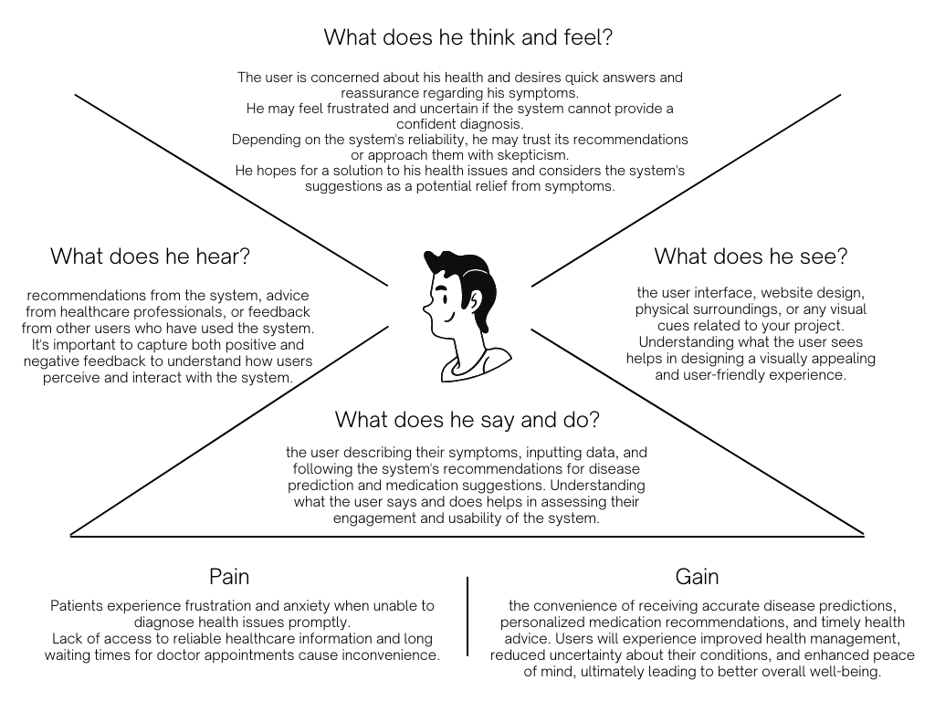

Use Case Diagram:

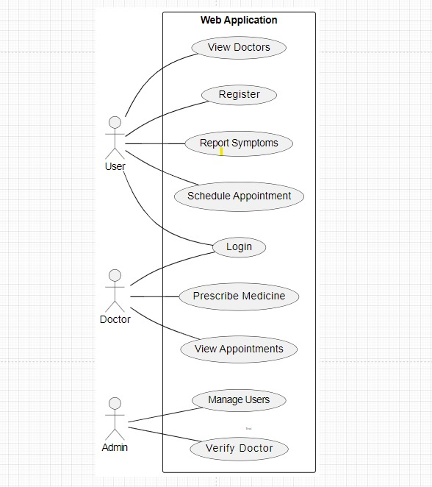

Class Diagram:

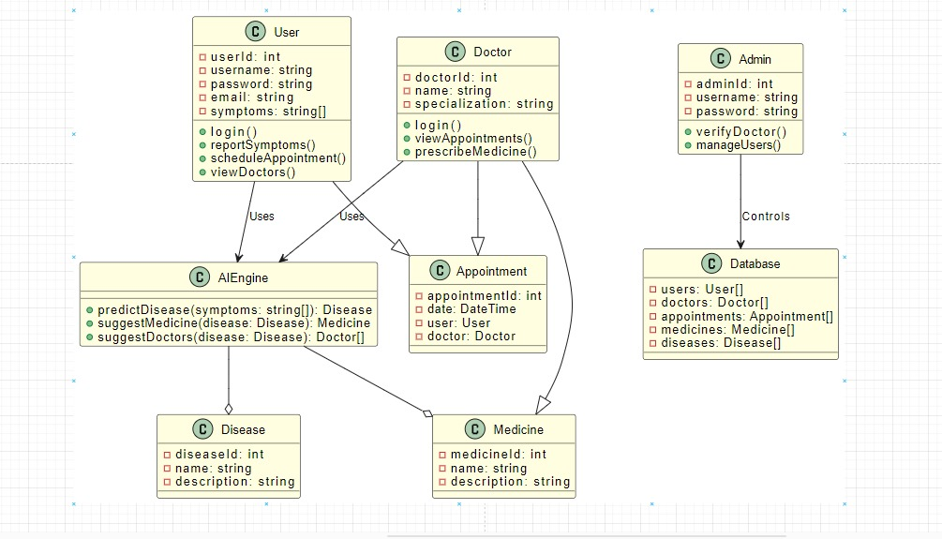

Activity Diagram:

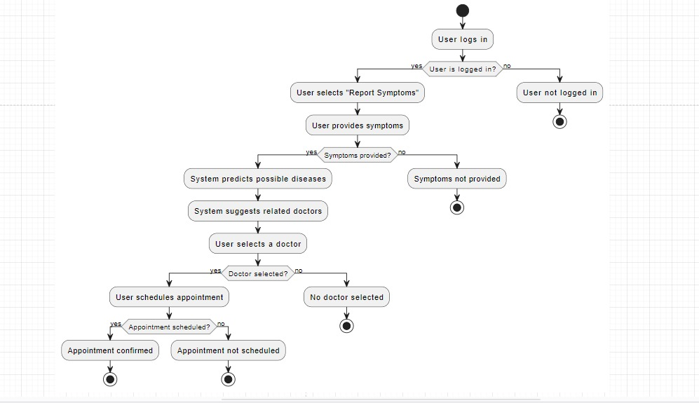

State Diagram:

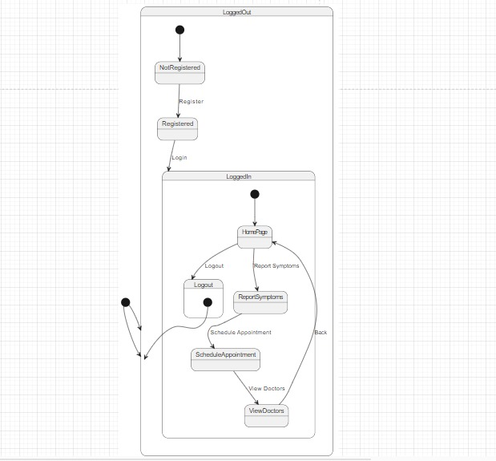

Sequence Diagram:

User

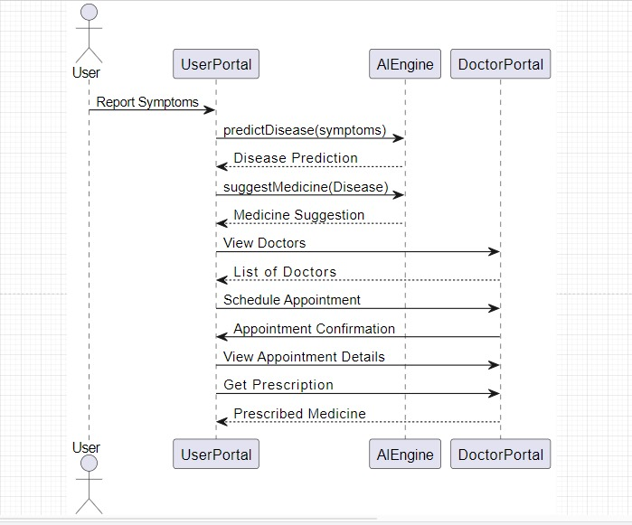

Sequence Diagram:

Doctor

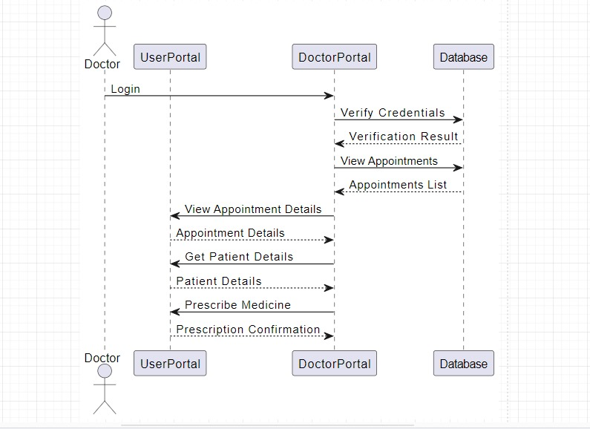

Component Diagram:

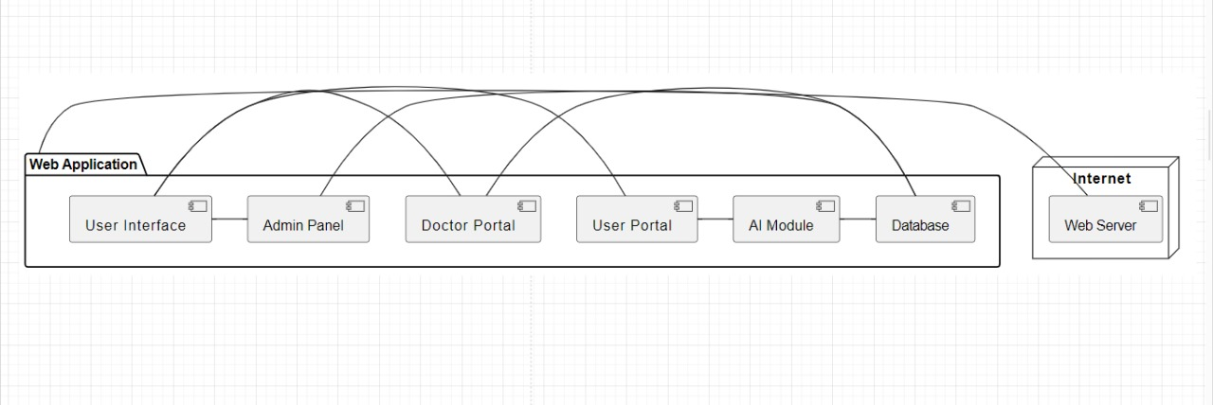

List of Faculty Proposed Changes
Project Title

Proposed Change | Proposed By | Supervisor’s Decision

Date: __________________ Supervisor’s Signature: _____________
APPROVAL
Project Supervisor
Comments: ___________________________________________________________________
_____________________________________________________________________________
_____________________________________________________________________________
_____________________________________________________________________________
Name:______________________________
Date:_______________________________ | Signature:__________________________

Project Manager
Comments: ___________________________________________________________________
_____________________________________________________________________________
_____________________________________________________________________________
_____________________________________________________________________________
_____________________________________________________________________________
Date:_______________________________ | Signature:__________________________

